SAMPLE PAPER - 01
Class 09 - Social Science

Time Allowed: 3 hours Maximum Marks: 80
General Instructions:
- There are 38 questions in the Question paper. All questions are compulsory.
- The question paper has Four Sections - A-History, B-Geography C-Political Science, and D-Economics.
- Each Section has MCQs, VSA, SA, LAs and CBQ.
- Very Short Answer Type Questions (VSA), carry 2 marks each. Answers to each question should not exceed 40 words.
- Short Answer Type Questions (SA), carry 3 marks each. Answers to each question should not exceed 60 words.
- Long answer type questions (LA), carry 5 marks each. Answers to each question should not exceed 120 words.
- There are case based questions (CBQ) with three sub questions and are of 4 marks each. Answers to each question should not exceed 100 words.
- The map-based questions, carry 5 marks with two parts- Q9. In Section A-History (2 marks) and Q19. In Section B -Geography (3 marks)
- There is no overall choice in the question paper. However, an internal choice has been provided in few questions. Only one of the choices in such questions must be attempted.

SECTION A HISTORY (20 marks)
- Who was the ruler of France? [1]

  - Louis XIV b) Louis XVI
c) Napoleon d) Robespierre
- On 14 July, the agitated crowd stormed and destroyed the Bastille. The place where Bastille is located is marked as A on the given map of France. Identify it from the following options.
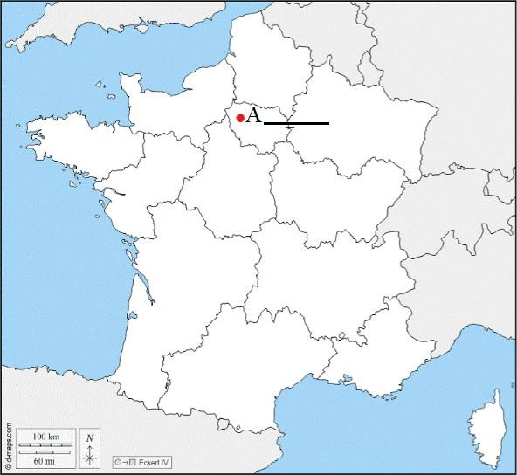

[1]

  - Paris b) Nantes
c) Bastille d) Marseillaise
- What was the main occupation of Russian people before the revolution? [1]
  - Industry b) Trade
c) Agriculture d) Minin
- Who was called whites during the Russian Civil war? [1]
  - Pro-tsarist b) The tsar's family
c) Russian women d) Socialist revolutionaries
- What do you know about the political clubs formed in France? [2]
OR
What was Guillotine? By whom and why was it used?
- Who was father Gapon? Narrate the events leading to the Bloody Sunday incident and the 1905 Revolution. [3]
OR
What was the impact of World War I on Germany's politics and society?
- What were the main causes of the French Revolution? [5]
OR
Describe the rise of the Jacobin club in France?

Read the given text and answer the following questions:

“The Third Estate was burdened with taxes, while the clergy and nobility enjoyed privileges. Food shortage and rising prices led to widespread hunger. On 14 July 1789, the people of Paris stormed the Bastille, a symbol of royal authority.”

Questions:

(a) Which estate paid the maximum taxes in France?

(b) Why was the Bastille stormed by the people?

(c) Name one cause of the food shortage mentioned above.

(d) What did the storming of the Bastille symbolize?
- Two places A and B have been marked on the given outline map of the world. Identify then and write their correct names on the lines drawn near them

[4]

[2]
- The place where they gave economic prosperity to the flourishing slave trade.
- The place where Territories under German expansion.
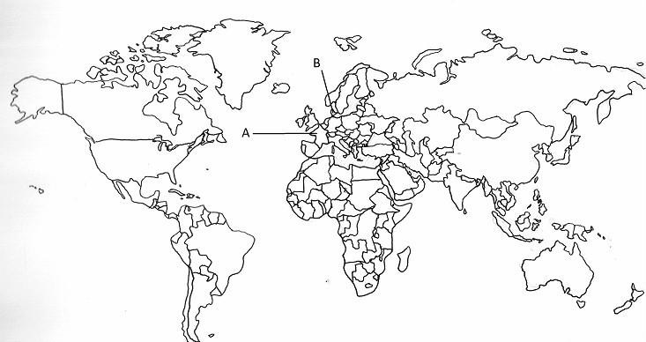

SECTION B GEOGRAPHY (25marks)
- Which of the following is the river island of Brahmaputra? [1]

  - Quibble island b) Majuli
c) Kabirvad d) Bhavani island

Census year | Sex ratio  (Females per 1000 males)
1951 | 946
1961 | 941
1971 | 930
1981 | 934
1991 | 929
2001 | 933
2011 | 943
- The following table represents India’s Sex Ratio between 1951-2011. Read the data and select the appropriate option from the following:

Which year has the most dismal figure in the given table?

[1]

  - 1981 b) 1951
c) 1991 d) 1971
- The area drained by a single river system is called.

[1]

  - Water Divide b) Drainge basin
c) River valley d) Flood Plain
- Find the odd one out with respect to Indus River System. [1]
  - Tibet, Mansarowar, Ladakh, Gilgit b) Zaskar, Nubra, Shyok, Hunza

- Ladakh, Jammu and Kashmir, Himachal Pradesh, Punjab
- Yamuna, Ghaghara, Gandak, Kosi
- Which factor does not affect the climate of India? [1]
  - Latitude b) Altitude
c) Distance from the sea d) Soil type
- Which Monsoon is resposnsible for winter rainfall in Tamil Nadu? [1]
  - South -West Monsoon b) North-East Monsoon
c) Western -Disturbances d) Local Wind
- What are the problems faced by adolescents in India? [2]
- Describe five characteristics/features of hot weather season in India. [5]
OR
The Development of tropical cyclones is a distinguishing feature of monsoon. How do tropical cyclones influence the distribution of rainfall in India?

Read the following text carefully and answer the questions that follow: [4]
“Tropical rainforests are found in regions receiving heavy rainfall. These forests have dense vegetation with tall trees
forming a canopy. A wide variety of animals such as monkeys, birds and reptiles are found here.”
Questions:
(i)Name the type of natural vegetation described.
(ii)Mention one climatic condition required for this vegetation.
(iii)Name any one animal found in these forests.
(iv)Why are these forests very dense?

- On the outline map of India locate and label the following with suitable Symbols.
- Any one of the following:
  - Chilika - Lakes
  - Simlipal - National Park
- Any two of the following:
- Sariska - Wild Life Sanctuaries
- K2 - Mountain Peaks
- Coastal Plains - Malabar

Q20 Difference between Himalayan River and Penisular River? (5)

SECTION C POLITICAL SCIENCE (20 marks)
20 Which of the following is true with reference to the Guantanamo Bay ?
- It is an area near Cuba controlled by American Navy.
- It is an centre of International Protection of Human Rights.

[1]
a) Both A and B are false b) Both A and B are true
c) A is false but B is true d) A is true but B is false
21 Which of the following is right expansion of the word MLA ? [1]
  - Member of Leaders Assembly b) Minister of Legal Assembly
c) Member of Legislative Assembly d) Member of Legal Assembly
- What is the date of adoption of the Constitution? [1]

  - 15th August, 1947 b) 30th January, 1960
c) 26th November, 1949 d) 26th January, 1950
23 Assertion (A): The Council of Ministers takes all major policy decisions in India.
Reason (R): The Prime Minister alone takes all decisions without consulting ministers..

[1]
  - Both A and R are true and R is the correct explanation of A.
  - Both A and R are true but R is not the correct explanation of A.
  - A is true but R is false. d) A is false but R is true.
24 a. When was National Human Rights Commission established?
b. Who appoints the Commission?
c. What are the main objectives of Commission?

[2]
- What are the qualifications to become a member of Lok Sabha? [2]
- Highlight some issues which bring many limitations and challenges of the Indian election to our attention. [3]
27 Describe the role of voters in an election . [5]
OR
Explain the challenges to free and fair elections in India?

Read the following text carefully and answer the questions that follow:

“Ravi was denied admission to a private school because he belonged to a backward community. The school claimed it had the right to choose its students.”

Questions:

Which democratic right is being violated here?

Which Article of the Indian Constitution ensures this right?

Why is this action unconstitutional?

What remedy is available to Ravi?

SECTION D ECONOMICS (15 marks)

- Consider a case of a small village near Karur town in Tamil Nadu. The village is facing a very poor condition. There are unmetalled roads in the village. Along with this, the village has no access to pure drinking water.
There is no clinic or a school in the village. Even people have to live without electricity. Subsequently, in order to curb such conditions, the central government assisted the state government and launched a scheme. After the implementation of the scheme, villagers have access to basic services such as primary health, primary education, rural shelter, rural drinking water, and rural electrification. Give the name of the scheme that lead the village to prosperity.

[1]
  - Mahatma Gandhi National Rural Employment Guarantee Act.
  - Swarnajayanti Gram Swarozgar Yojana
  - Antyodaya Anna Yozana d) Pradhan Mantri Gramodaya Yozana

- What is FCI? [1]

  - Food Corporate of India b) Functional Corporation of India
c) Food Corporation of India d) Functional Corporate of India

Name of Scheme | Year of  introduction | Coverage target  group | Latest Volume | Issue Price  (Rs per kg.)
PDS | Up to 1992 | Universal | - | Wheat (W): 2.34  Rice (R): 2.89
RPDS | 1992 | Backward blocks | 20 kg of foodgrains | Wheat: 2.80  Rice: 3.77
TDPS | 1997 | Poor and non-poor BPL  APL | 35 kg of foodgrains | BPL  W: 4.15, R:  5.65  APL  W: 6.10, R:  8.30
National Food Security Act (NFSA) | 2013 | Priority households | 5 kg per person per month | Wheat: 2.00  Rice: 3.00  Coarse grains: 1.00
- Read the given table that shows some important features of PDS in India. Read the data and select the appropriate option from the following.

[Source: Economic Survey]
The target of which scheme was to provide the benefits of PDS to remote and backward areas?

[1]

  - PDS b) NFSA
c) TDPS d) RPDS
- Identify the policy with the help of the given information:
This policy states that human being is a positive asset and a precious national resource which needs to be

[1]
cherished, nurtured and developed with tenderness and care, coupled with dynamism. Each individual’s

growth presents a different range of problems and requirements.
  - National Education Policy b) Sarva Siksha Abhiyan Policy
c) Health and family welfare policy d) Insurance Policy
- "Poverty is a curse upon humanity." Explain by giving examples. [3] [3]
- One historical reason is the low level of economic development under the British colonial administration. Explain. [3]

- What is the impact of unemployment? [5]
OR
Do you think that people appear employed in disguised unemployment?

